Zyrardow 0103.2015

To everyone interested in subject of electric vehicles.

Mr Tomasz Wierzchon
6b Kutnowska St.
96-300 Żyrardów

Mobile: +48 606116824

Forum administrator
„Żyrardów dla wszystkich”
www.zyrardow24h.eu
also
Forum administrator
“forum.arbiter.pl”
www.forum.arbiter.pl

INVITATION TO ELECTRIC VEHICLES EXHIBITION

On the weekend of 9 – 10 May 2015 at the Zyrardow cycling track located on 13 Stefana Zeromskiego Street, will take place five exhibition of all sort of electric vehicles. This year Zyrardow again is pleased to be able to host this spectacular event.

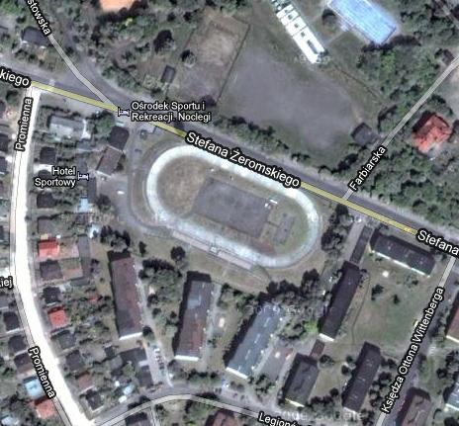
Stefana Żeromskiego 13, Żyrardów, Poland
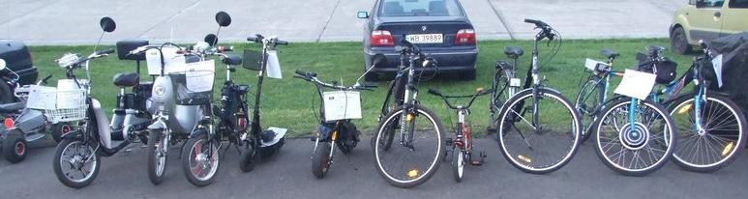
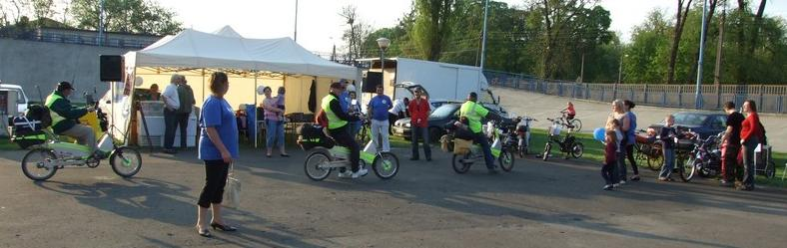
This year’s exhibition, as the previous one, will have a less formal character (more like camping, picnic) than meetings in hotels or any other official locations. We would like people passionate about EVs to gather together and have a good time and laugh over a pint of famous polish beer and grilled sausage.

The event is open to everyone, especially the ones involved in construction of electrical vehicles, passionate in modifying, converting fossil fuel vehicles into battery powered, and industry representatives - manufacturers of electric vehicles and batteries, electricity suppliers interested in providing infrastructures for charging of electric vehicles. Exhibition is aimed at all persons and institutions interested in development of greener cars in Poland and abroad.

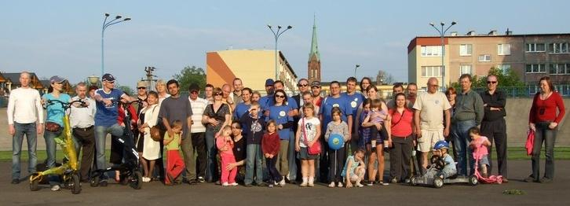
The most obvious advantage of electric car batteries is that they do not produce the pollution associated with internal combustion engines. Although more expensive to buy, electric cars are cheaper to run than conventional ones. People like electric cars because they provide a very quiet ride and the maintenance of electric cars is also much easier to handle.

As mentioned earlier, the exhibition will be held on a cycling track - currently unused, which suits perfectly commercial purposes.
You have to come and test-drive one of those great vehicles yourself!
There is a hotel nearby and quite a few local shops. Camping character of the rally and great area where you can set up your tent is a great opportunity to socialise with other electric cars enthusiasts.

For your convenience there is a hostels just outside the cycling track. http://www.zyrardow.pl/redir:209
Organiser provides electricity (single-phase and three-phase), medium sized tent which could be used as a canteen or for any other purpose needed.


If you are interested in taking a part in our exciting event please email: zeeltom@gmail.com or call +48 606116824 (Thomas). Free entry! Organiser offers free stands and power.
Accommodation and living costs are not included (but fairly cheap). We would like to remind you again about the camping character of the rally. You can find more information at http://forum.arbiter.pl and http://zyrardow24h.eu .

See you there!

Kind Regards:
Tomasz Wierzchon

